SLD Dashboard Test Report - Automated Proof Test
Test conducted by: Ahmed Elnemr, Marco Turdo
SLD Dashboard version: 1
Timeframe for testing: 02/2025 – 03/2025

Test Groups
- Test group name is updating correctly.
- Test group description is updating correctly.
- Test group type is updating correctly.
- Test interval is updating correctly.
- Test duration is updating correctly.
- Overdue is updating correctly.
- Field worker is updating correctly.
- Last test column is updating correctly.
- Due date column is updating correctly.
- HIMA Intern: Next scheduled is not working.
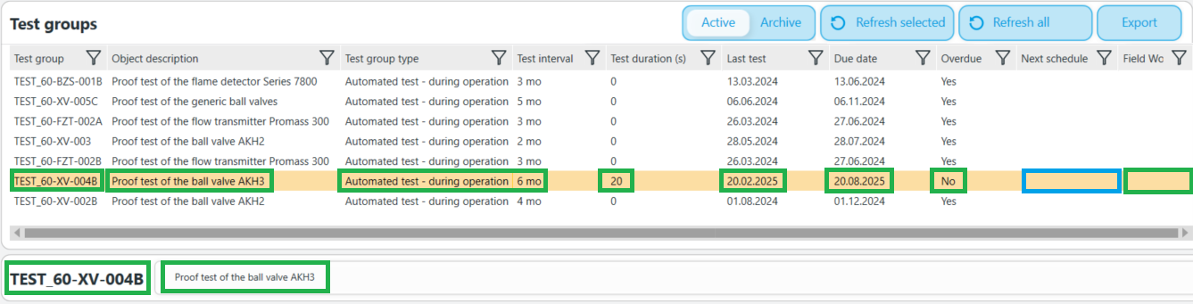

Test Overview & Projection
- Donut shape is updating correctly.
- Number of Overdue is updating correctly.
- Number of On schedule is updating correctly.
- Number of Automated tests is updating correctly.
- Number of Manual tests is updating correctly.
- Projection is updating correctly.

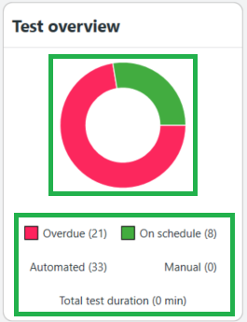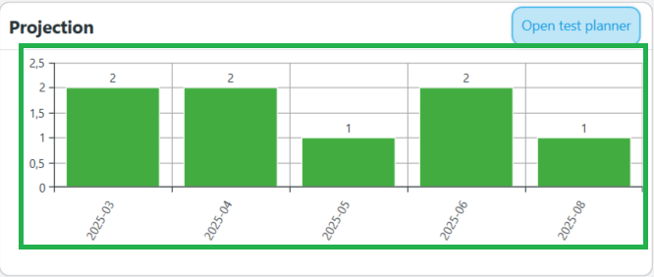

Test group scope items:
- Open test procedure is working correctly.
- Open details is working, and the rule behind is:
  - Global Alias Name: Tagnumber
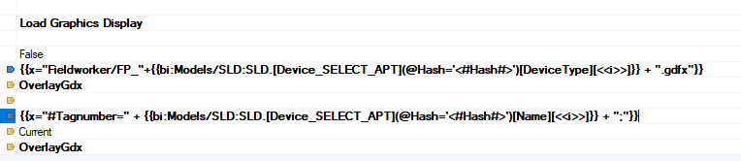
- Tag number is updating correctly.
- Type is updating correctly.
- Generic model is updating correctly.
- Bypass active is updating correctly.
- Start test is working correctly.
- Test started is updating correctly.
- Test result is updating correctly.
- Test date is updating correctly.
- Test result code is updating correctly.
- Test duration is updating correctly.
- Conducted by is updating correctly.
Test group information:
- Test type is updating correctly.
- Affected SIF is updating correctly.
- Last approved test date is not updating.
- Last approved test result is not updating.
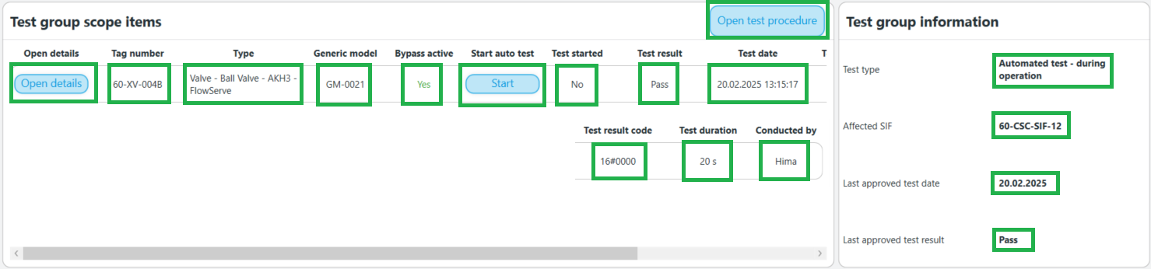
Test Events (Log):
- Test events are correctly logged.
- Test Payloads are correct.
Approving the events:
- Event Status is updating.
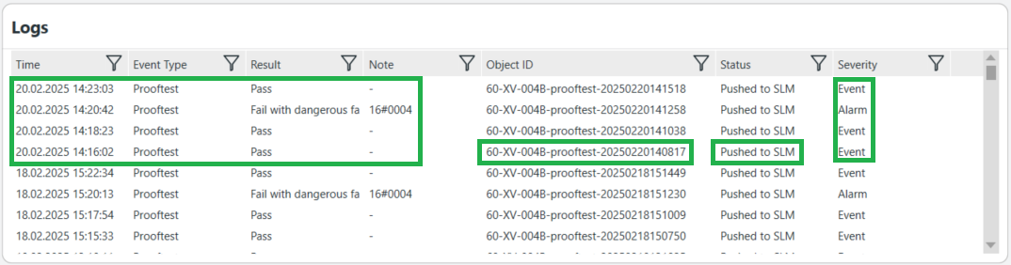

Journal:
- Journal is updating correctly.

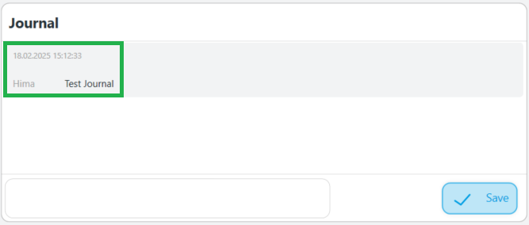

Open Test Planner:
- HIMA Intern: Open test planner need to be finalised!

